CHRISTINGLE COLOURING PAGE

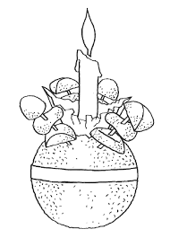

COLOURS YOU WILL NEED:
Orange – for the orange Red – for the ribbon
White – for the candle Yellow – for the flame
Any colours for the rest …… You choose

